Development of site assistant for students

Matvei Sukhikh   
Department of Computer Systems and Technologies  
National Research Nuclear University MEPhI (Moscow Engineering Physics Institute)Moscow, Russian Federation  
Vulkii@yandex.ru

Vlada Prikhodchenko  
Department of Computer Systems and Technologies  
National Research Nuclear University MEPhI (Moscow Engineering Physics Institute)Moscow, Russian Federation  
lamparuv@mail.ru

Andrey Vladimirov  
Department of Computer Systems and Technologies  
National Research Nuclear University MEPhI (Moscow Engineering Physics Institute)Moscow, Russian Federation  
andrey.vladimirov.95@mail.ru

*Abstract -* The article is devoted to web resource development, which will be useful for students and teachers. This article presents basic methods and structures, which are used in the research. Here are using Python, Django, HTML, CSS, creating databases and analysis of the influence of different colours shades on human. The main goal of the research is creating a site template, which is easy to adapt and integrate into various educational institutions.

Keywords – web resource; Django; HTML; CSS; colours.

# Introduction

At the beginning of 2020, about five billion people used the Internet – a World Wide Web of computer networks for operating with information [12]. Moreover, every day the number of active users is growing, the World Wide Web penetrates every home and every area of our lives. However, what made the Internet so natural nowadays? In addition to being one of the quickest methods of trading information, it is available to nearly everyone, and anyone can bring something of their individual in it. Also, the most significant reasons for using it are convenience and versatility. If a user does not like a particular web resource or a person has his own opinion that can change something, it can be easily implemented into the World Wide Web [13].

Due to 2020’s shifts in the world, diverse employees, including students from multiple institutes work from their homes. However, they need to have much beneficial information that is pretty challenging to obtain on the Internet on a single centralized source, in the interpretation that they require. As a rule, each learner demands assistance in understanding the material which was passed as well as finding further information on training programs.

Constructing a website that brings together people who can help students is a very vital task today. Such web resource allows learners to receive assistance in solving their queries in a short time, as well as quickly accessing relevant tutorial materials for various subjects.

# Research Materials And Methods

It was necessary to determine an environment where the user’s interface and functionality would be developed and to define everything that the users of the site see when they open the web resource. PyCharm was chosen as the development environment. This is one of the best IDE for Python. It is simple to work with Git in it. It has an exceptionally convenient and pleasant interface, the automatic ending of multiple commands. Also, a lot of Django templates have got autocomplete as well. It is pretty clear to understand how to organize a project in this environment. Even a person who is far from programming will comprehend it.

Each web resource consists of two components: the frontend part and the backend part.

## Backend

Such languages as PHP, Python, JavaScript, Java, .NET, C#, Go, and countless others can be used to implement the first one of two parts. Django web framework was chosen for the research because it is a very traditional environment for developing web applications. It has numerous advantages which can be highlighted, for example [3-10]:

* excellent documentation, which is extremely easy to understand;
* simple scalability;
* great safety;
* well-developed ecosystem.

The speed with which various works are written in this framework is much higher than its analogues, which makes it attractive in research projects.

## Frontend

The frontend part of the site is implemented on such languages as HTML, CSS, and JavaScript [11]. The last one permits people to make the site lively, add different variants of the site’s responses to various user operations.

HTML is used to provide all kinds of information to the learner, and CSS is used to connect a specific style to structured documents. HTML tells the browser how to draw the site pages and how to show information on them. HTML code elements are similar to containers. They provide specific information about the text and the images to the user. This container consists of a header, a description of the web resource and its content.

The SQLite database was selected to save various data. First of all, the main advantage is that it is elementary to edit and migrate (since initially, the database is a single file in the site directory). It also has many built-in functions, and it is exceptionally reliable.

During the research, it was decided to use shades of dark colours on the site. This solution has a lot of advantages [1,2]:

* information that is written on a dark background is more comfortable to be read by the user;
* dark colours reduce eye pressure in low-light places;
* dark pixels consume less power on devices, where they are used.

## Database

Additionally, an individual database of people who are ready to help students to study various educational programs for free was collected. A survey was chosen as the most appropriate method of collecting this information. It is a method of collecting original report based on indirect interaction between the researcher and the interviewee. The survey was conducted on specialized service – Google Forms. Initially, several hosting services were selected to test. The trial period on each of them was initialized. After that, the site was uploaded on the hosting, and some tests were performed. The result of these test gave the top-3 possible hosting services.

The site was uploaded to one of the possible hosting sites to detect some errors. Real students wished to be testers. All of their responses were structured according to charts and various tables, which made it possible to see the user response and respond to it instantly. One of the worthy suggestions was to add a photograph of the National Research Nuclear University MEPhI on the background of the Web page. A vast number of options were tested, and some of them were edited in photoshop to find the most suitable one. These options contain different hue shades, resolutions, and the location of the photo on the site pages.

# Results

A template for the site was obtained as a result of the research. This template was developed for the National Research Nuclear University MEPhI. Every person can quickly adapt it to any university.

A registration window was realized. It adds the user to the database after passing it (Fig. 1):

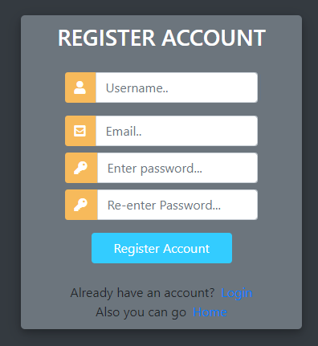

Fig. 1. Registration window

Also, a login window, which compares login information with the data in the database, was implemented (Fig. 2):

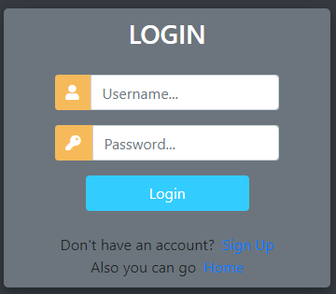

Fig. 2. Login window

Besides, an adaptive sidebar menu was created (Fig. 3):

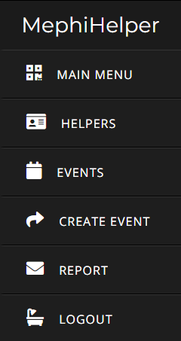

Fig. 3. Sidebar

A section of the site where people can see several events taking place at the university was implemented. Special access rights have been added, and they have been combined into a group that can be requested by a particular user to edit this section (Fig. 4):

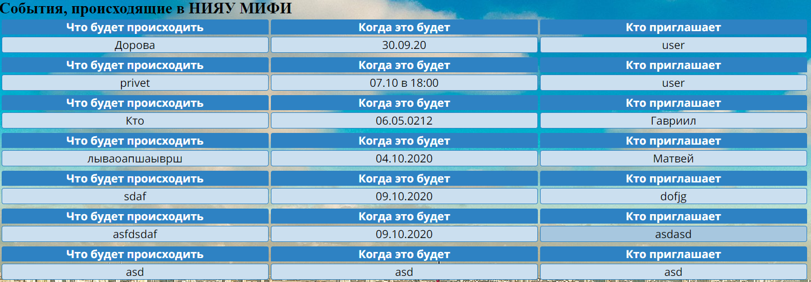

Fig. 4. Table of the events

A real photo of the National Research Nuclear University MEPhI is displayed on the background of the site (Fig. 5):

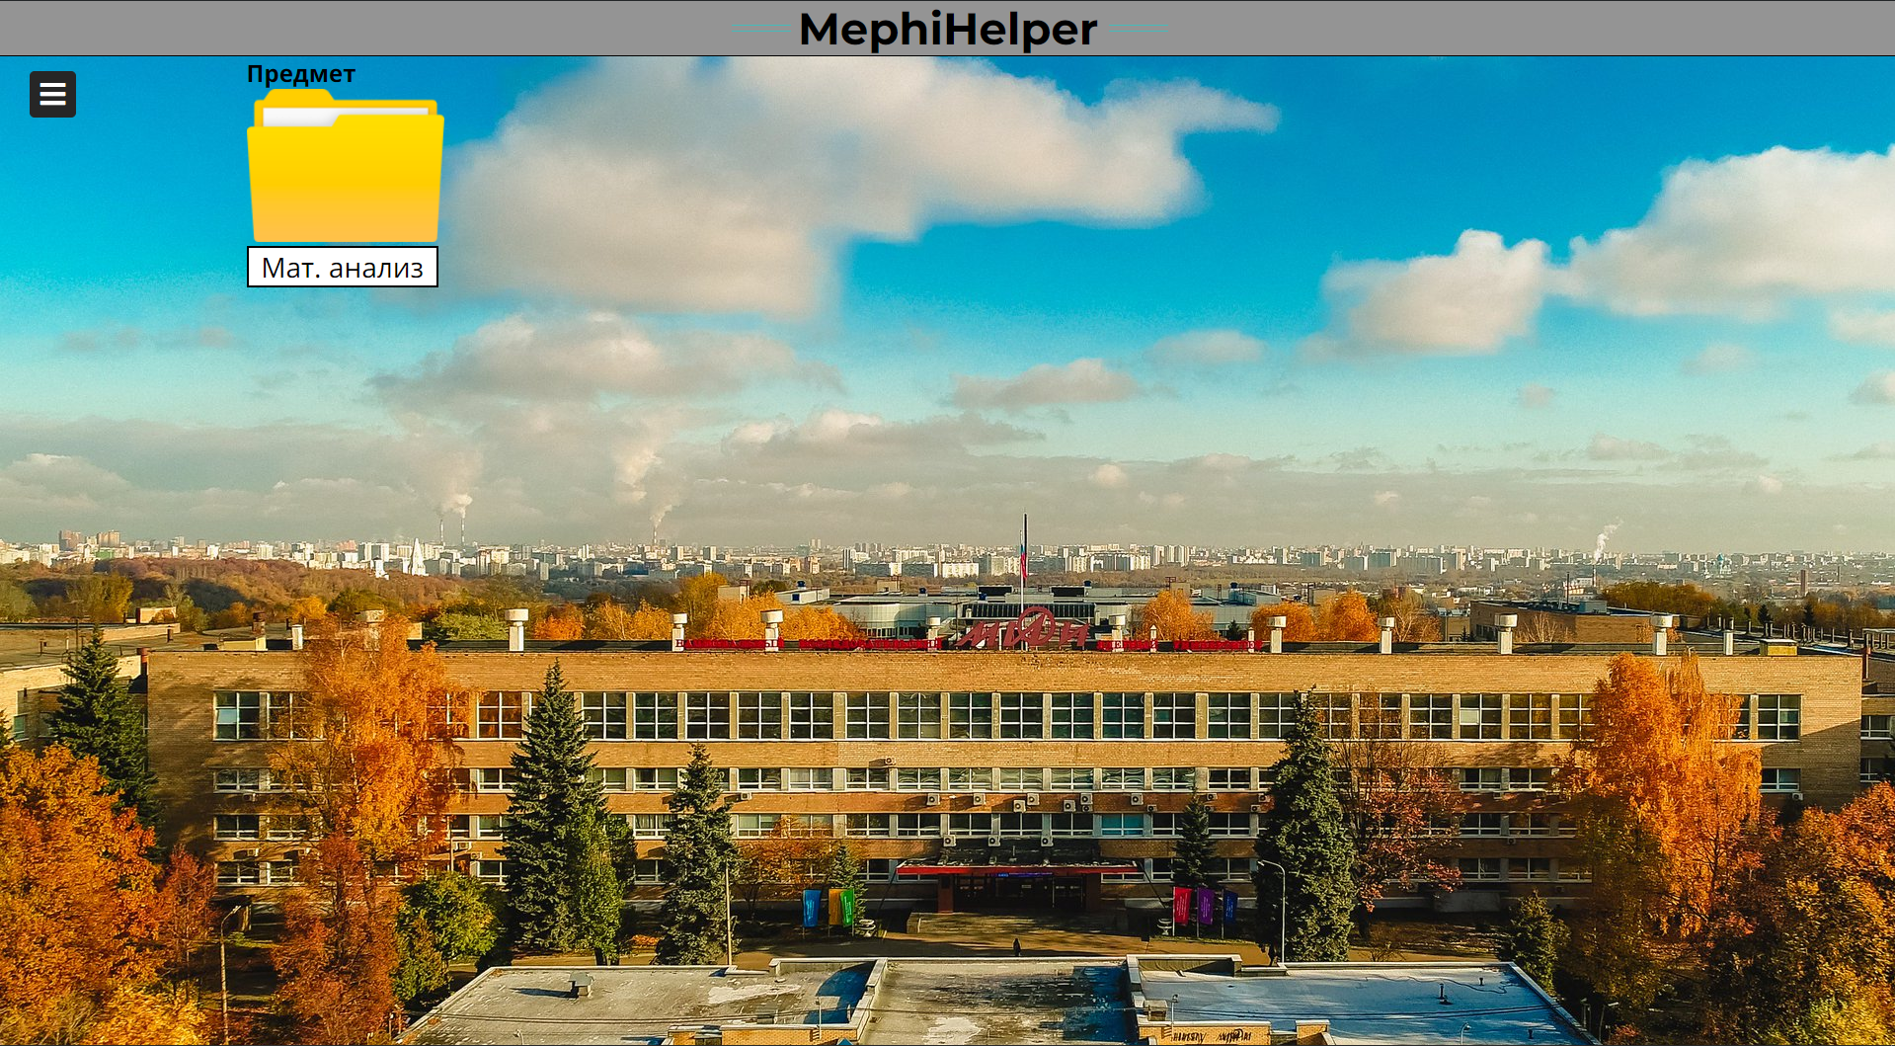

Fig. 5. Background of the site

Of course, it can be easily changed on any other photo.

The site header, which consists of a grey background, the name of the web resource, and four turquoise lines was completed (Fig. 6):



Fig. 6. Head of the site

A feedback system has been built to guarantee personal contact with the site creator who can fix any glitches or bugs. It may also receive various suggestions for improving the web resource. The link is presented in the form of hyperlinks through images to the creator’s social networks (Fig. 7):

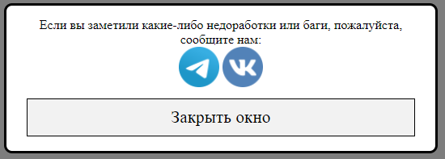

Fig. 7. Report window

A system of contacting with helpers, where are shown the first and last names of each helper, the subject with which he provides support, the person, who taught him and the course that he can assist with was performed (Fig. 8):

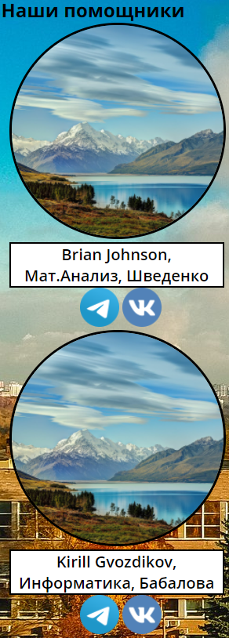

Fig. 8. Helper’s window

A folder system provides learners with the necessary information in a short time. These folders transfer students to the selected folders on Google Drive that contains various training materials was created (Fig. 9):



Fig. 9. Folder

The site was released on the Internet and verified by a mass user. Due to the tests which were performed, there are no errors in the site’s operation or other shortcomings.

In addition to all of the above, a unique database of people, who were ready to provide students with support in obtaining additional information and mastering it in various educational programs, was formed. This database is actual for the 2020 year for the National Research Nuclear University MEPhI.

This site can be easily improved by adding an internal database of files, to use it with no references to other sources. It is only possible if a better hosting will be used because the site requires an expensive hosting service with a large amount of memory stored. This improvement will develop the stability of the site because for its standard operating user’s device should be connected with only one host.

The administrator of the site can also correct the colours of different objects, add some shadows for details, and several animations to make the site more lively and pleasant for the user.

The excellent add-on to the site will be an internal chat between users and helpers, which will be private.

Each version of the site was uploaded on GitHub, from where everyone can easily download the source code of the site and use it as they wish, even create their website, and use it as it was intended.

The web resource has various access rights that allow people to make changes to the event database. For example, one of them is a special “Eventor” group, the assignment of which automatically adds all access rights associated with changing information in the event-related database. These rights were only issued to verified people who used them for their intended purpose (Fig. 10):

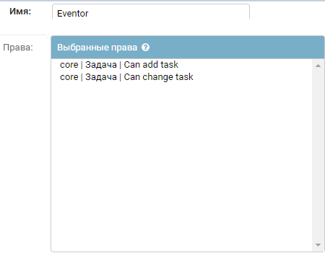

Fig. 10. Group rights (for Eventor)

These users have access to a particular page where they can add events. Such user needs to write the name of the activity that will take place, the date when it will be, and the name of the person who invites students to the event. It should be noted that Eventors can write the name of any person in the last field, but in the administrative panel remains their username, and all information that they wrote (Fig. 11):

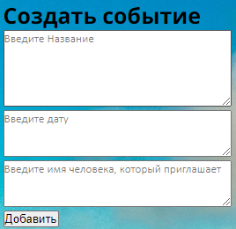

Fig. 11. Create an event table

Events that were added this way can be easily edited from the administrative panel (Fig. 12):

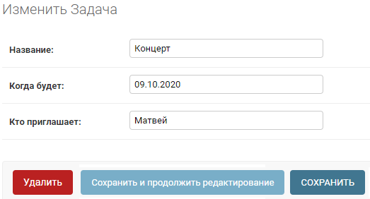

Fig. 12. Edit event table

# Discussion And Conclusions

The study resulted in a user-friendly website where learners can quickly find materials for academic subjects, as well as contacts of people who can help with solving educational issues. The web portal can significantly facilitate the learning process.

This study solves the problem of the lack of a centralized database of people who are ready to help in getting an education and showed its relevance because five students expressed a desire to help in just two days. A superior service, Google Forms, was selected for the survey. It is very convenient and also immediately systematizes all user responses, which allowed to transfer them to the site database successfully. This survey showed that there are people who want to help learners for free. The questionnaire was performed among volunteers of the National Research Nuclear University MEPhI.

The information obtained from the survey helped to determine how the real users react to various changes on the site, find out what is missing for the average user, and add the missing tools to the site. Additionally, it showed people real relevance of the resource like that in every university in the world. All responses really showed it, and all of them were glad to see a web resource like this.

This study was conducted to help other people make a website with all the necessities which learners need in nowadays world.

##### References

1. Elliot A. J., Maier M. A., Color Psychology: Effects of Perceiving Color on Psychological Functioning in Humans. Annual Review of Psychology, 65(1), 95–120p., 2014. DOI: 10.1146/annurev-psych-010213-115035
2. Stoll M, Baecke S., Kenning P., What they see is what they get? An fMRI-study on neural correlates of attractive packaging. Journal of Consumer Behavior, 7(4–5), 342–359p., 2008, DOI: 10.1002/cb.256
3. Holovaty A, Kaplan-Moss J., The Definitive Guide to Django, St. Petersburg, Piter Publ., p. 97, 2010, (in Russian)
4. Antonio Mele Packt, Publishing Django By Example, 24 p., 2014.
5. [Ryabokova K.M.](https://www.elibrary.ru/author_items.asp?refid=537497746&fam=%D0%A0%D1%8F%D0%B1%D0%BE%D0%B2%D0%B0&init=%D0%9A+%D0%9C),  DJANGO framework: architecture and opportunities//Modern technologies: topical issues, achievements, and innovations: the collection of Articles XIII of the International academic and research conference in 2 h Part 1. - Penza: MCNS ‘‘Science and Education’’, Page 118 – 120, 2018.
6. [Forcier](https://www.elibrary.ru/author_items.asp?refid=537497747&fam=%D0%A4%D0%BE%D1%80%D1%81%D1%8C%D0%B5&init=%D0%94) D., Django Development of web applications on Python. Trans. By Kiselev A., St. Petersburg, Symbol-Plus, = 456 p., 2009
7. Dronov V., Django 2.1 The practice of creating websites on Python. St. Petersburg, BHV-Petersburg, 523 p., 2019 (in Russian)
8. Dronov V., Django: The practice of creating websites on Python. St. Petersburg, BHV-Petersburg, 523 p., 2016 (in Russian)
9. Dawson M., Programmable on python. - St. Petersburg: Peter, 416 p., 2014
10. Summerfield M., Programming on Python 3. Detailed manual. - Per. from English - St. Petersburg: Symbol Plus, 2009. - 608 p., 2009
11. Duckett J., HTML и CSS. Development and design of websites per. From the English M. A. Reitman. - M.: Eksmo, 480 p., 2013.
12. Digital 2020: global digital overview (2020). Available at: https://datareportal.com/reports/digital-2020-global-digital-overvi